Resistor sorting robotic arm

We could have an image of our arm here maybe?

|  |  |
| --- | --- |
| Name | Student ID |
| Dominic Pennycook | 19006106 |
| John Nicola | 19007312 |
| Saad Khan | 20010279 |
|  |  |
|  |  |
|  |  |

Contents

Contents 1

Project management 2

Risks and Management 2

Team allocation 3

Planning and Scheduling 4

Progress monitoring and Coordination 5

High-level design 5

Top-Level System Design 5

- Presentation of top-level system design. 5

High-Level Mechanical Design 5

High-Level Software Design 5

High-Level Electrical Design 5

Requirement Analysis 5

Traceability 5

Low-Level Design 5

Implementation 6

Low-Level Documentation 6

Traceability 6

Verification and Validation (V&V) 6

V&V Plan 7

Evidence 7

Reflection and Evaluation 7

Strengths of our project 7

Weaknesses of our project 7

Next steps in our start-up 7

What we would do differently next time 7

Insert a table of figures after content – in the references tab under captions

[Figure 1 - Risk Characterisation Table 3](https://uweacuk-my.sharepoint.com/personal/dominic2_pennycook_live_uwe_ac_uk/Documents/Year%203/GDIP/GDIP%20report.docx#_Toc121217057)

[Figure 2 - Risk Key 3](https://uweacuk-my.sharepoint.com/personal/dominic2_pennycook_live_uwe_ac_uk/Documents/Year%203/GDIP/GDIP%20report.docx#_Toc121217058)

[Figure 3 - Risk's and Mitigation Plans 3](https://uweacuk-my.sharepoint.com/personal/dominic2_pennycook_live_uwe_ac_uk/Documents/Year%203/GDIP/GDIP%20report.docx#_Toc121217059)

[Figure 4 - Role Breakdown 4](https://uweacuk-my.sharepoint.com/personal/dominic2_pennycook_live_uwe_ac_uk/Documents/Year%203/GDIP/GDIP%20report.docx#_Toc121217060)

[Figure 5 - Work Breakdown Structure 5](https://uweacuk-my.sharepoint.com/personal/dominic2_pennycook_live_uwe_ac_uk/Documents/Year%203/GDIP/GDIP%20report.docx#_Toc121217061)

[Figure 6 - Project Gant Chart 1 6](https://uweacuk-my.sharepoint.com/personal/dominic2_pennycook_live_uwe_ac_uk/Documents/Year%203/GDIP/GDIP%20report.docx#_Toc121217062)

[Figure 7 - Project Gant Chart 2 6](https://uweacuk-my.sharepoint.com/personal/dominic2_pennycook_live_uwe_ac_uk/Documents/Year%203/GDIP/GDIP%20report.docx#_Toc121217063)

|  |  |
| --- | --- |
| Abbreviation | Meaning |
| RSA | Resistor Sorting Arm |
| V&V | Verification and Validation |
| MVP | Minimum Viable Product |
| V&V | Verification and Validation |
| RMP | Risk mitigation plan |
|  |  |
|  |  |
|  |  |
|  |  |

# Introduction

## Purpose of the report

Due to the complex nature of the project and the high level of interest from stakeholders this report was created showing the process’s taken to ensure the products feasibility and suitability to the problem proposed and the project scope laid out later. Each section will aid in the completion of future project as well as show the suitable steps in an engineering projects lifecycle were completed to a high level. Important parts of the project management are included and the last key section of the report allows a deeper dive into what could be improved for future projects and what lessons were learnt.

## Scope of the project

The resistor sorting arm (RSA) needed to quickly and accurately sort through a group of resistors with minimal human assistance. The arm needed to measure resistor resistance in a set location, pick the resistor up and move it to the correct box. While our MVP works with the E12 resistor series modifications too the code would allow an easy change to a different set of resistors and with more altering additional boxed could be added allowing more different resistors too be sorted.

## All necessary documentation

GitHub was used extensively throughout the project allowing all pertinent documentation to be stored in one location. Use of software similar to GitHub allows excellent version control and advanced team collaboration and allowing individuals to produce documentation at their own rate. The link to this projects GitHub repository is XXX, and the can be found in the uploaded documentation on blackboard. The necessary password is XXX

# Project management

## Risks and Management

From the onset of the project risks were being assessed and added to the risk mitigation plan. Initially a comprehensive list of all related risks was created and then added to through the project, each team member regularly reviewed the plan and made sure it was still suitable. The risk was categorised using Figure XX & XX2, then using conditional formatting in excel it was it was simple to understand which risks were most dangerous to the project. Each of the initial risks were use in creating the Gantt chart and allowing additional time to events which had a higher likely hood of being delayed.

Figure 1 - Risk Characterisation Table

Figure 2 - Risk Key

Figure 3 - Risk's and Mitigation Plans

The Verification and Validation (V&V) plan (covered later in this report) was vital to the success of the project. V&V allowed the confirmation that all sections accomplished were traceable to the system and high-level design, and also completed their intended outcome, without adding bloat to the project. As V&V was so vital to the project the robust plan was formed early on and rigidly maintained throughout the venture.

The Design risks heavily rely on a vigorous V&V plan, through this the likelihood of a project delaying/cancellation issue is extremely unlikely. This is further evidence of the need for a competent V&V plan. Legal and contractual issues would be a greater issue past this project’s scope and after the production of the minimum viable product (MVP) but designing the arm from scratch will minimise these issues. Economic issues are largely out of the control of the start-up, however suitable mitigation in the case of an issue is still needed and provided. Through continued discussion with the stakeholders, described in the High-level design section, there is an undersaturated market for this product and minimal competition. However, if the market decreased/becomes oversaturated this could financially cripple the company so continued talks are necessary. As with any product, a suitable look into health and safety in the manufacture and use of the product is necessary and the necessary documentation will be provided for both.

The RMP was regularly updated periodically in conjunction with the project and GitHub as used for version control ensuring all different stages of the plan were saved and could be accessed if needed. As the RMP was created originally at the beginning of the project all team members knew what the risks were and how to avoid them happening allowing the project to complete smoothly with minimal issues.

## Team allocation

At the start of any project, it is vital to determine and define the team structure and roles, making sure everyone in the team understands their responsibility and roles. This breakdown is detailed in Figure XX 4). To further emphasise each team members roles and responsibility a responsibility matrix was created (Figure XX 5). This level of planning allowed team members to know what they needed to complete and who had the information to help them, also allowing individual members to make sure everyone else had completed their section.

Figure 4 – Team structureA screenshot of a computer

Description automatically generated

Figure 5 - Responsibility matrix

## Planning and Scheduling

- Planning and scheduling

Figure 6 - Work Breakdown Structure

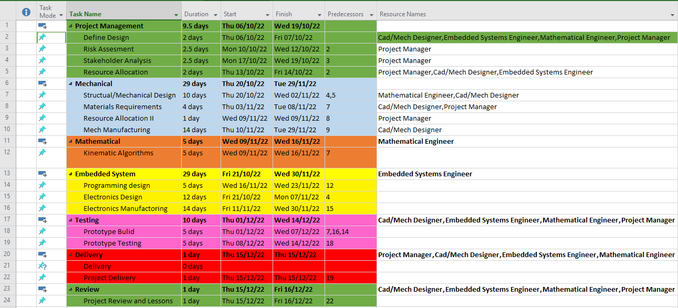

Figure 7 - Project Gant Chart 1

Figure 8 - Project Gant Chart 2

## Progress monitoring and Coordination

During the project weekly meetings were held and comprehensive meeting minutes were taken, as seen in the GitHub repository. This allowed everyone to know what had been discussed and also what they need to complete in order to stay on track and complete the project in time. Any task that was not completed for any reason was moved too the next weeks minutes and the project manager followed up with help to make sure they were completed. This use of meeting minutes on GitHub gave clear instructions to every team member on what was necessary to be completed, when uploaded to GitHub the meeting minutes document was available to everyone and any changed that were made would be visible.

# High-level design

## Top-Level System Design

*- Presentation of top-level system design. Clear presentation of top-level system design. Clear presentation of high-level design of the main subsystems (e.g. software, electronics). High level designs address all requirements appropriately.*

Top level system design and high-level design require conversation with the stakeholders, to ensure all stakeholders are considered each team member had a template stakeholder analysis which allowed multiple stakeholders and their importance along with other metrics which decided their allocation in the stakeholder management document. With each team member independently conceiving a stakeholder analysis the likelihood of a potential stakeholder being missed is drastically reduced allowing a more exhaustive management of the stakeholders. All members included the electronics technical help team at the University of the West of England as a key stakeholder providing the unique possibility to have their opinion every week during the meetings held. This close management of a key stakeholder allowed the project to stay on track and gave very good system and high level design criteria.

Figure 9 - Stakeholder Analysis

Utilising the stakeholder analysis and either talking directly to the stakeholder or using our tutor as that stakeholder a list of all the requirements (Figure XX) was created and the stakeholder sign off was used. This requirements list document allowed a clear view of what was desired by the clients and what we needed to do to complete the project to satisfaction. Once the stakeholders, the UWE Fet Team and a representative group of hobbyists, had read the requirements list any changes were made and the document was signed off.

Figure 10 - Requirements list

## High-Level Mechanical Design

- Presentation of high-level design of the main subsystems (e.g. software, electronics).

## High-Level Software Design

- Presentation of high-level design of the main subsystems (e.g. software, electronics).

## High-Level Electrical Design

- Presentation of high-level design of the main subsystems (e.g. software, electronics).

## Requirement Analysis

'- Requirements analysis

## Traceability

The High Level design requirements were specified from user requirements, as is corroborated by the Requirements list. This list was form in collaboration with various stakeholders to produce a comprehensive idea of what the robot was required to complete. Each high-level design has a direct link to s system level design validating that the stakeholders would want it.

# Financial, Regulatory and Intellectual Property considerations

# Low-Level Design

## Implementation

'- Lower-level specifications and implementations to address the requirements.

* description of the process for developing and implementing the low-level designs, including justification of key decisions.

Things to include: create specifications that each design must fulfil, and mark against design

Justification of the base – why we created a base/ its purpose - mechanical

Why we created an electromagnetic gripper, process of coming to that conclusion, difficulties with a mechanical based gripper - mechanical

How the gripper works - electrical

Reason for having a treadmill/ something to put resistors on (idk what its actually called) - mechanical

How we measured the resistance/ why we did it this way? - electrical

Explanation of kinematics code – software

Maybe should also include some stuff on the programming?

Have a sequence diagram of how the outside world interacts with our robot and how it interacts with the world

* Will look into this

## Low-Level Documentation

- Clear and accessible documentation of low-level designs.

Gripper, base design, maybe some electromagnet stuff

## Traceability

Figure 11 - High -> Low level design with traceability

# Verification and Validation (V&V)

## V&V Plan

The V&V plan ensures that the end product is designed and built well and what the customer desired. To accomplish this a competent V&V plan was created at the onset of the project and strictly adhered to, this relied heavily on the V&V matrix (Figure XX) and the individual sign off.

A V&V matrix (Figure XX) allows for every key aspect of the project to be officially tested and verified to both work, and contribute to what is desired by the stakeholders. Each of the high-level designs and the lead team member(s) are listed with the ID of the verification used and whether this provided full of partial coverage. The different verifications used are found on the next sheet (Figure XX) and these describe the actions taken and are referenced using ID tags for ease of use. The V&V plan was used throughout the project and shows how successful the project was.

Figure 12 - V&V Matrix

Figure 13 - Verification Methods

At the end of each project management document a box is displayed which has a location for each member of the team to sign indicating they have reviewed the document and agreed that it is up to standard. Figure XX shows the document sign off box, it is a clear indication that the document has been reviewed and quality checked. In addition to the team member sign off certain documents have a stakeholder sign off which shows a stakeholder has checked the document and that it reaches the standards that are expected (Figure XX). These two boxes verify that what they represent is verified to what is wanted from the customer and also that it is a good solution to the problem.

Figure 14 - Document sign off box



Figure 15 - Stakeholder sign off

## Evidence

Both the Document sign off’s and the V&V matrix provide evidence that the whole of the project has been quality checked and meets the standards of both the team and the stakeholders.

# Reflection and Evaluation

## Strengths of our project

- Thoughtful and accurate assessment of strengths and weaknesses in your group's design process.

## Weaknesses of our project

- Thoughtful and accurate assessment of strengths and weaknesses in your group's design process.

## Next steps in our start-up

What we would do to make the product more viable

- Identification of key lessons in generalised terms that can be applied to future projects.

## What we would do differently next time

- Identification of key lessons in generalised terms that can be applied to future projects.

For future projects a more indepth review into what the customer wants as well as a larger V&Vplan would be beneficial.